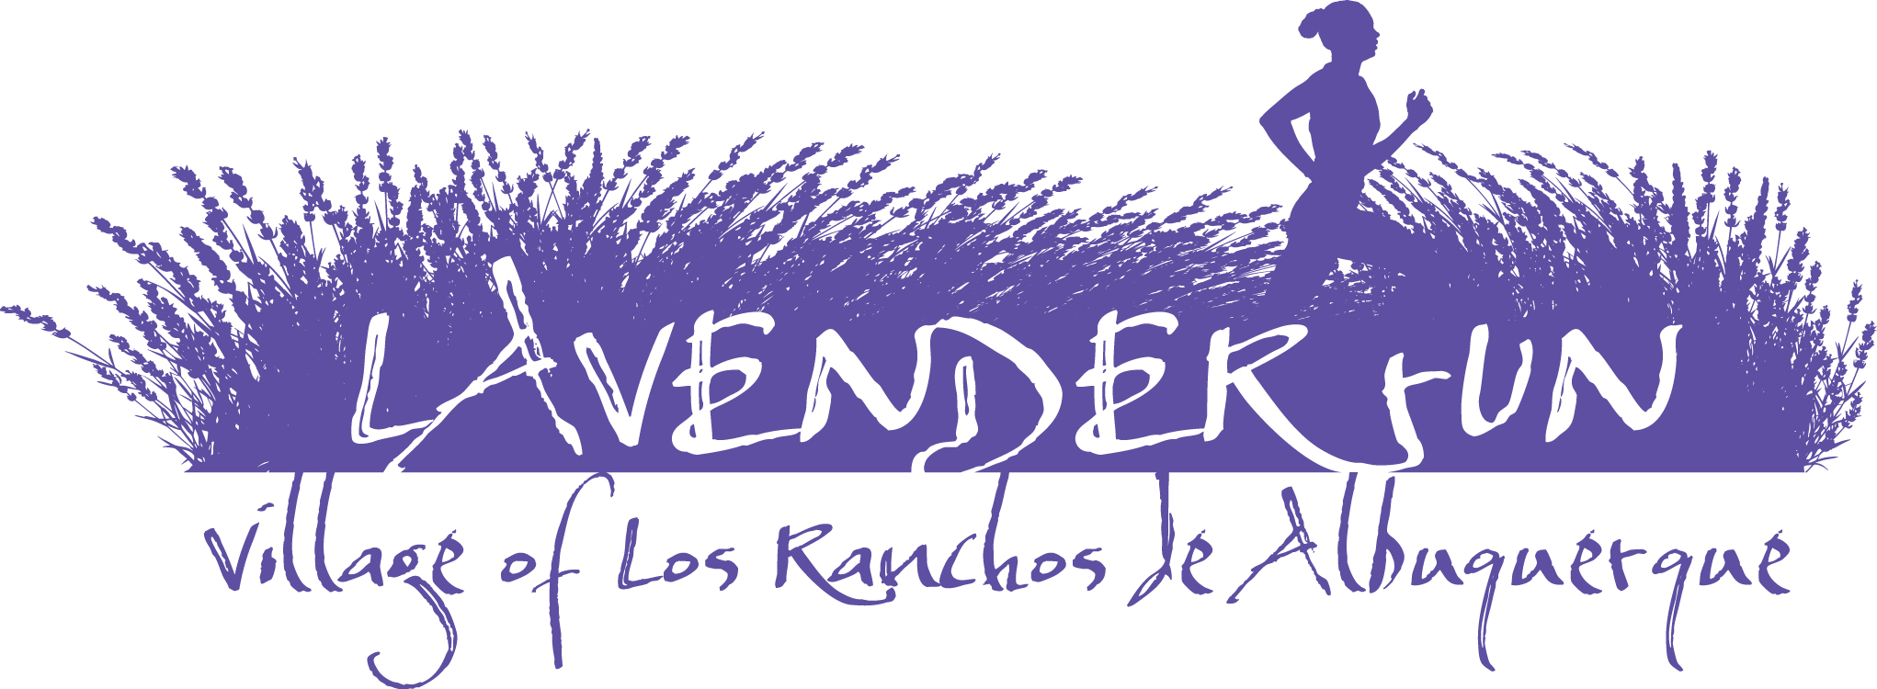

LAVENDER RUN
EVENT INFORMATION
Event Location:
Alvarado Elementary School
1100 Solar Rd. NW
Albuquerque, New Mexico 87107

IMPORTANT: NO PARKING AT ALVARADO ELEMENTARY: See “PARKING”.

Event Schedule:
Sunday: July 12, 2026
10K: 8:00 a.m.
5K: 8:15 a.m.
Kids K: 9:00 a.m.

Runner Packet Pick-up and Late Registration:
Saturday, July 11, 2026
Time: 11:00 TO 3:00 P.M.
Fleet Feet Sports
5901 Wyoming Blvd. NE
Albuquerque, NM 87109

Lavender Run participants (13 and over) will receive complimentary entry into the 19th annual Lavender Festival on Saturday, July 25, 2026. The Lavender Festival includes live music, free yoga classes, a Kids Camp, wellness seminars, cooking demonstrations, and 70 artisans offering everything from lavender bouquets to lavender paintings, pies, spices, lotions, beer, and wine. A perfect day for lavender lovers of all ages.

THERE IS RACE-DAY REGISTRATION; HOWEVER, ALL PRE-REGISTERED PARTICIPANTS MUST PICK UP THEIR EVENT PACKETS AT “PACKET PICK-UP.”
If you are not able to pick up your packets in person, you must decide for a representative to pick up your packet. Any out-of-town participants may pick up their packet on race morning at the registration area at Alvarado Elementary School.
START:
The Lavender Run will start in front of the Alavardo Elementary School. NOTE: ALL PARTICIPANTS WHO WOULD LIKE TO BE ENTERED IN THE RESULTS AND BE ELIGIBLE FOR AWARDS MUST WEAR A TIMING CHIP/BIB.
Note: All races will start promptly at the designated times listed above. Allow plenty of time to get to the Start to seed yourself according to your projected pace time. If you are driving to the race plan to arrive early. See parking information below.
The 10K and 5K Run or Walk use a Gun Start with a Timing Chip finish. The "official time" will start when the gun/horn goes off.
PARKING:
Los Poblanos Open Space: 5601 Tierra Viva Pl. NW, Albuquerque, NM 87107
Hartnett Park: 6718 Rio Grande Blvd. NW, Albuquerque, NM 87107
Note: Start and finish of the 10K, 5K and Kids K is in front of Alvarado Elementary School
Alvarado Elementary School: 1100 Solar Rd. NW
NOTE: THERE IS NO PARKING AT ALVARADO ELEMENTARY SCHOOL OR ON THE ROADS (NABOR RD. AND SOLAR RD). PLEASE USE THE ABOVE PARKING LOCATIONS.
​
NOTE
PLEASE USE DESIGNATED PARKING AREAS ONLY. DO NOT PARK ON ROADS OR ON COURSE.

Bathroom Facilities:
Port-a-potties are located near start/finish. Please allow plenty of time prior to the race start times to use the restroom.

Race (Bib) Number Requirements:
Each participant will receive a Race (Bib) number that must be worn on race day. DO NOT alter your race number in any way. Your bib number must be visible and worn on the front outside of all clothing during the entire race so that it may be clearly seen. Bib numbers are non-transferable and MUST be worn by the runner to whom it is assigned.

Medical Support:
Medical staff members will be ready to assist you at any time. Radio communications personnel will be positioned at every aid/water station along the course.
Event officials have the right to withdraw any runner from the race who appears to be in distress or at risk. If you have a health or medical problem at the Finish Line, please notify event officials or volunteers. Please cooperate if you are asked to go for a checkup. If you need help at any point, please ask. If you are unable to finish the race for any reason, please notify a race official of your bib number so that the medical personnel are aware.
Can I run with an iPod/headphones?
Yes. USATF, the national governing body of the sport, recently amended its ban on headphones, iPods, and similar devices. However, athletes competing for prize money are not permitted to use electronic devices, including headphones and earpieces.
Can I run with my GPS device?
Yes, participants may wear their GPS watches. However, these items do not count as “second timing devices" and will not be recognized by the event as official times or distances.
What is NOT allowed on the course?
The use of video devices, cell phones, computers, cameras or any similar devices by participants in the event is prohibited. The use of wheeled devices by participants or any other person authorized to be on the course shall be strictly limited to: (a) authorized course marshals on bicycles. Skateboards, rollerblades, unauthorized bicycles or any other wheeled device will not be permitted.
Are baby joggers and strollers allowed?
If you choose to run with a baby jogger, you must stay behind all other runners. It is your responsibility to make sure your baby jogger or stroller does not impede other runners, and you must take extra precautions to ensure your safety, your child’s safety, and the safety of the runners around you. We reserve the right to remove any participant from the race who endangers other runners or themselves. Note: Your child must always be secured in a jogger or stroller.
Do you have a Lost & Found in case I lose something at the Event or on the racecourse?
Yes. We will have a Lost & Found for items lost or found on race day. If you are missing a personal item, please call: 505.217-4774.
I am injured and/or cannot run the event (family commitment, work obligation, etc.). Can I request a refund, donate my entry, or transfer it to someone else?
No. Sale and/or transfer of race entry/bib are strictly prohibited and will result in the disqualification and/or banning of any individuals involved from future events. All entry fees are non-refundable and cannot be deferred toward a future event.
If I provide medical documentation of my injury or pregnancy, will you give me a refund?
No. Please refer to our official event rules and guidelines.
Can I defer my entry to the next year if I am unable to run this year?
No, participants cannot defer their entries to the next year if they are unable to run.
Can a friend pick up my packet for me if I cannot attend Packet Pickup?
Yes. Your friend can pick up your packet.
Are dogs allowed?
Yes. However, please make sure the dog is on a short leash.

Inclement Weather Policy:
Weather forecasts will be monitored prior to the event, paying special attention to the possibility of heavy rain, thunder and lightning, high winds, and extreme temperatures. If necessary, athletes will be notified on the RunFit website (www.irunfit.org) so they can prepare for severe weather and potential course alterations during the race. Severe weather updates will also be sent to participants via email as necessary. The Race Director will monitor the weather and decide whether to take any action to modify the race. Possible changes include adjusting the race start time or, in extreme cases, canceling the event. Please listen closely to all public address announcements at the starting line of the race. Visible lightning will postpone the race for a minimum of 15 minutes. Additional sightings will continue to delay the race in 15-minute increments. If extreme heat is forecast, additional water will be provided to athletes before, during, and after the event. The medical team will be alerted that athletes may require additional medical attention during and after the event due to the high temperatures.

Finish Information:
The timing chips you will be wearing are disposable and do not need to be returned. The overall and division award winners will be announced at the Awards Ceremony on race day – immediately following the Kids K. Award times will be determined by gun time.

10K:
Overall prizes will be awarded to the top three men and women determined by gun time.
Age group prizes will be given to the top three finishers in the following categories for men and women: 19 and under, 20-24, 25-29, 30-34, 35-39, 40-44, 45-49, 50-54, 55-59, 60-64, 65-69, 70-79, 80+.

5K:
Overall prizes will be awarded to the top three men and women determined by gun time.
Age group prizes will be given to the top three finishers in the following categories for men and women: 9 and under, 10-12, 13-15, 16-19, 20-24, 25-29, 30-34, 35-39, 40-44, 45-49, 50-54, 55-59, 60-64, 65-69, 70-79, 80+. Award times will be determined by gun time. Award times will be determined by gun time.

Kids K:
All registered participants (11 and under) are eligible to participate in Kids K. The start of Kids K will begin at 9:00 a.m., immediately after 5K. The race director will make an announcement 15 minutes before the start to ensure all Kids K participants arrive on time. The start of Kids K will be near the RunFit finish arch. All participants will receive a special recognition award upon completion.

Post-Race:
Refreshments and Awards

COURSE:
Courses will be well marked with volunteers and aid stations.
Note: Cut and Paste Hyperlink in Browser

10K: LAVENDER RUN 10K 2026 - MapMyRun

5K: LAVENDER RUN 5K 2026 - MapMyRun

Results: All results will be posted immediately at: www.irunfit.org

Volunteer Information:
Volunteers are still needed to help! Please contact RunFit at (505) 217-4774 to volunteer for race day or email: stephenpino@hotmail.com

Thank-a-volunteer campaign!
The Lavender Run is fortunate to have some of the friendliest and hardest-working volunteers around. Volunteers help us on race morning to ensure you feel welcomed, are fully informed and have a safe, successful, and positive running experience, and more! When you have a chance, give a hearty, fun-loving thanks!

Race Questions and Information:
RunFit
12104 Palm Springs Ave. NE
Albuquerque, NM 87111
(505) 217-4774
Email: stephenpino@hotmail.com RunFit Website: www.irunfit.org

